Lecture 2
Different Forms of Data

  - Numeric Data: numbers

  - Categorical Data: limited, and usually fixed number of possible values based on some qualitative property.

  - Ordinal Data: ordered list. Ex: clothing sizes such as small, medium, and large.

Properties of Data

- Volume: Scale of Data.
- Variety: Different forms of data.
- Velocity: Rate of data streaming and generation.
- Value: Meaningfulness of data in terms of information.
- Veracity: Certainty and correctness in data.

How to Clean Data
Step 1: Removing Duplicate or Irrelevant Observations
Step 2: Fixing Structural Errors
Step 3: Filtering Unwanted Outliers
Step 4: Handling Missing Data
Step 5: Validation

Stemming Vs Lemmatization
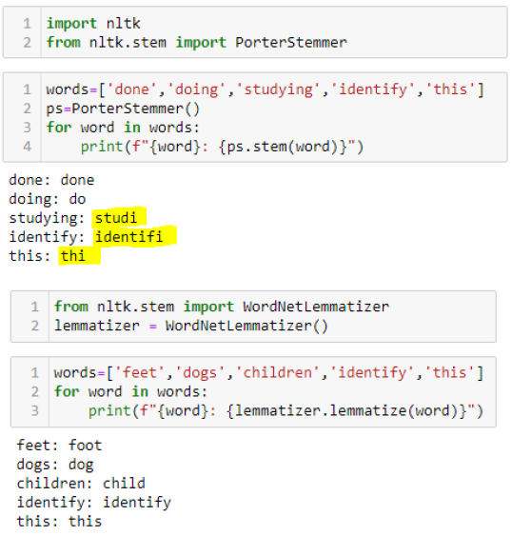
  - Stemming: Process of removing last few characters from a word, often leading to incorrect meanings and spelling.
  - Lemmatization: Considers the context and converts the word to its meaningful base form, which is called Lemma.

  - Independent variables are the input for a process that is being analyzed.
  - Dependent variables are the output of the process.
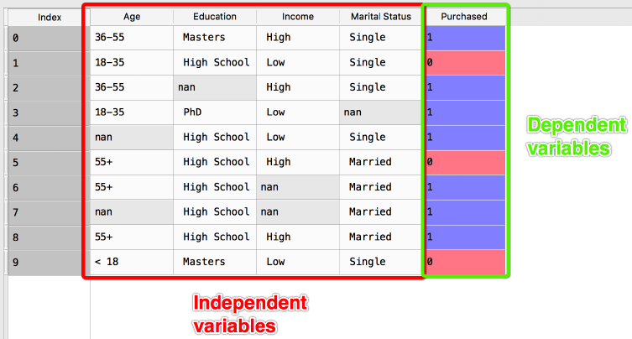

Preparing Your Dataset for ML

- Articulate the problem early.
- Establish data collection mechanisms.
- Check your data quality.
- Format data to make it consistent.
- Reduce data.
- Complete data cleaning.
- Create new features out of existing ones.
- Rescale data.

Training, Validation & Testing Data

Training data
- Responsible for building up the machine learning algorithm.
- The data scientist feeds these data, which corresponds to an output.

Validation data
- During training, validation data infuses new data into the model that it hasn’t evaluated before.

Test data
- After the model is built, testing data once again validates that it can make accurate predictions.
- If training and validation data include labels, the testing data should be unlabeled.
Overfitting vs Underfitting
Overfitting:
- Good performance on the training data, poor generalization to other data.
- A high accuracy measured on the training set.

  - Underfitting:
- Poor performance on the training data, poor generalization to other data.
- Reduces accuracy and produces unreliable predictions.

Dimensionality Reduction

Reducing the number of random variables by obtaining a set of principal variables.
Eliminating redundancy and reducing the possibility of the model overfitting.
  - Two components:
- Feature Selection -Smaller subsets of features are chosen by filtering, wrapping, or embedding.
- Feature Extraction -Reducing the number of dimensions in a dataset to model variables.

When to use Dimensionality Reduction?
Dimensionality reduction shall be used before feeding the data to a machine learning algorithm to achieve the following:
- It reduces the size of the space in which the distances are calculated, thereby improving machine learning algorithm performance.
- It reduces the degrees of freedom for our dataset avoiding chances of overfitting.
- Reducing the dimensionality using dimensionality reduction techniques can simplify the dataset facilitating a better description, visualization, and insight.
Principal component Analysis (PCA)
What are the principal components?
- Principal components are the derived features which explain the maximum variance in the data.
- The first principal component explains the most variance, the 2nd a bit less and so on.
- Each of the new dimensions found using PCA is a linear combination of the old features.
Why PCA?
- To compress a dataset onto a lower-dimensional feature subspace.
- Feature selection finds a subset of features while PCA produces a smaller new set.
- Helps us to identify patterns in data based on the correlation between features.
- PCA aims to find the directions of maximum variance in high-dimensional data.

Applications of PCA
- Visualize multidimensional data.
- To reduce the number of dimensions in healthcare data.
- Can help resize an image.
- Used in finance to analyze stock data and forecast returns.
- PCA helps to find patterns in the high-dimensional datasets.

Lecture 03
Random Forest
- Random Forest is a popular machine learning algorithm that belongs to the supervised learning technique.
- It can be used for both Classification and Regression problems in ML.
- It is based on the concept of ensemble learning, which is a process of combining multiple classifiers to solve a complex problem.
- Random Forest is a classifier that contains several decision trees on various subsets of the given dataset.
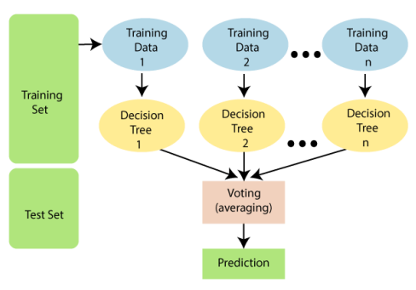
Why Random Forest?
- It takes less training time as compared to other algorithms.
- It predicts output with high accuracy, even for the large dataset it runs efficiently.
- It can also maintain accuracy when a large proportion of data is missing.
Applications of Random Forest
- Banking
- Medicine
- Land Use
- Marketing
Pros & Cons of Random Forest
Pros | Cons
It can perform both Classification and Regression tasks. | Although random forest can be used for both classification and regression tasks, it is not more suitable for Regression tasks.
It is capable of handling large datasets with high dimensionality
It enhances the accuracy of the model and prevents the overfitting issue.

Lecture 04

Support Vector Machine
- Popular Supervised Learning algorithms for Classification as well as Regression problems.
- Goal is to create the best line or decision boundary that can segregate n dimensional space into classes.
- This best decision boundary is called a hyperplane.
- SVM chooses the extreme points/vectors that help in creating the hyperplane.
- Extreme cases -> support vectors.
- The distance between the vectors and the hyperplane is called as margin
- The goal of SVM is to maximize this margin. The hyperplane with maximum margin is called the optimal hyperplane.

Types of SVM
Linear SVM
Used for linearly separable data.
If a dataset can be classified into two classes by using a single straight line.

Non-linear SVM
- Used for non-linearly separated data.
- If a dataset cannot be classified by using a straight line, then such data is termed as non-linear data.
- For non-linear data, we will add a third-dimension z.
- z can be calculated as 𝑧=𝑥2+𝑦2.
SVM:
Face detection
Image classification

Lecture 05
Regression Analysis in Machine Learning

- Regression analysis is a statistical method to model the relationship between a dependent and independent variable.
- Regression helps to understand how the value of the dependent variable is changing.
- It predicts continuous/real values such as temperature, age, salary, price, etc.
- A supervised learning technique which helps in finding the correlation between variables.
- We plot a graph between the variables which best fits the given datapoints.
- Regression shows a line or curve that passes through all the datapoints.
- The distance between datapoints and line tells whether a model has captured a strong relationship or not.

Dependent Variable:
The main factor which we want to predict is called the dependent variable. Also called target variable.

Independent Variable:
The factors which affect the dependent variables, or which are used to predict the values of the dependent variables, also called as a predictor.

Outliers:
Outlier is an observation which contains either very low value or very high value in comparison to other observed values.

Multicollinearity:
If the independent variables are highly correlated with each other than other variables, then such condition is called Multicollinearity.
It creates a problem while ranking the most affecting variable.

Underfitting and Overfitting:
If our algorithm works well with the training dataset but not well with test dataset Overfitting.
If our algorithm does not perform well even with training dataset Underfitting.

Importance of regression analysis.

- Regression estimates the relationship between the target and the independent variable.
- Used to find the trends in data.
- Helps to predict real/continuous values.
- Can confidently determine the most important factor, the least important factor.

Types of Regression
Linear Regression Decision Tree Regression
Random Forest Regression Logistic Regression
Polynomial Regression Ridge Regression
Support Vector Regression Lasso Regression

Linear Regression
- Statistical regression method which is used for predictive analysis.
- Shows the linear relationship between the independent variable (X) and the dependent variable (Y).
- One input variable (x), then such linear regression is called simple linear regression.
- More than one input variable, then such linear regression is called multiple linear regression.
Uses of Linear regression
- Analyzing trends and sales estimates.
- Salary forecasting.
- Real estate prediction.
- Arriving at ETAs in traffic.

Logistic Regression
- Supervised learning algorithm which is used to solve the classification problems.
- Logistic regression algorithm works with categorical variables.
- Predictive analysis algorithm which works on the concept of probability.
- Logistic regression uses sigmoid function or logistic function which is a complex cost function.
- The sigmoid function is used to model the data in logistic regression.
- 𝑓(𝑋) = 1/1+𝑒^{−𝑥}
- f(x) = Output between the 0 and 1 value.
- x = input to the function
- e = base of natural logarithm.
- The S-curve will be as follows.

Types
Binary(0/1, pass/fail)
Multi(cats, dogs, lions)
Ordinal(low, medium, high)

Lecture 06
Use cases of Clustering
- In the Identification of Cancer Cells
- In Search Engines
- Customer Segmentation
- In Biology
- In Land Use
- Image recognition – identify parts of an image that belongs to the same object.
Types of Clustering:
- Partitioning Clustering
- Density-Based Clustering
- Distributional Clustering
- Hierarchical Clustering
- Fuzzy Clustering
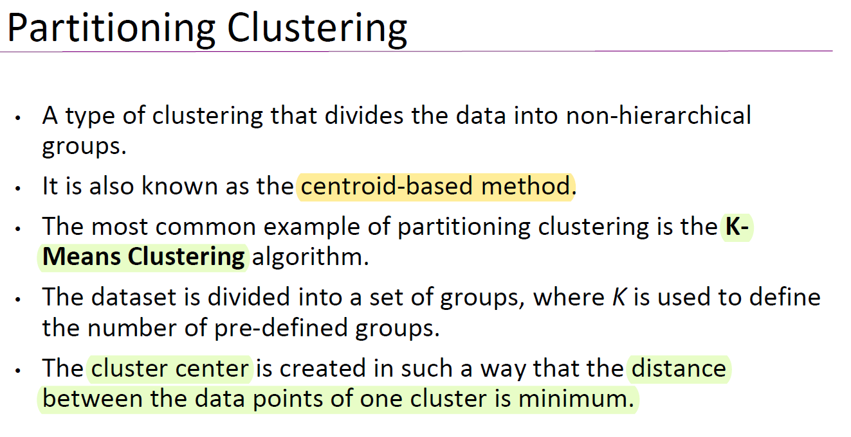

K-Means Algorithm
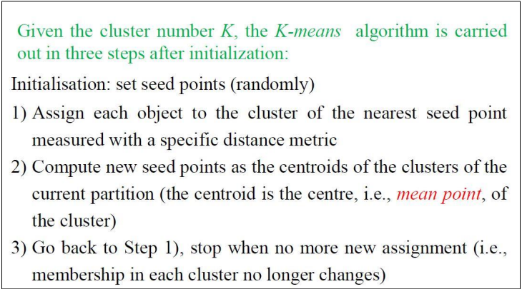
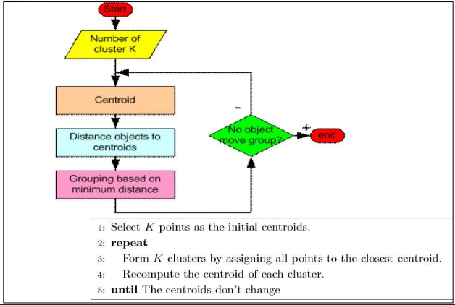
Distributional Clustering
- The data is divided based on the probability of how a dataset belongs to a particular distribution.
- The grouping is done by assuming some distributions commonly Gaussian Distribution.
- An example of this type is the Expectation-Maximization Clustering algorithm.
- This is based on Gaussian Mixture Models (GMM).

Hierarchical Clustering
- In this algorithm, we develop the hierarchy of clusters in the form of a tree.
- This tree-shaped structure is known as the dendrogram.
- Sometimes the results of K-means clustering, and hierarchical clustering may look similar.
- The hierarchical clustering technique has two approaches: Agglomerative & Divisive.
*Refer lec slides again

Lecture 07
Association Mining

Finding frequent patterns, associations, correlations, or causal structures among sets of items or objects in transaction databases, relational databases, and other information repositories.

- “IF buys beer and sausage, THEN also buy mustard with high probability”.
- “On Thursdays, grocery store consumers often purchase diapers and beer together”.
- “Customers who purchase maintenance agreements are very likely to purchase large appliances”.
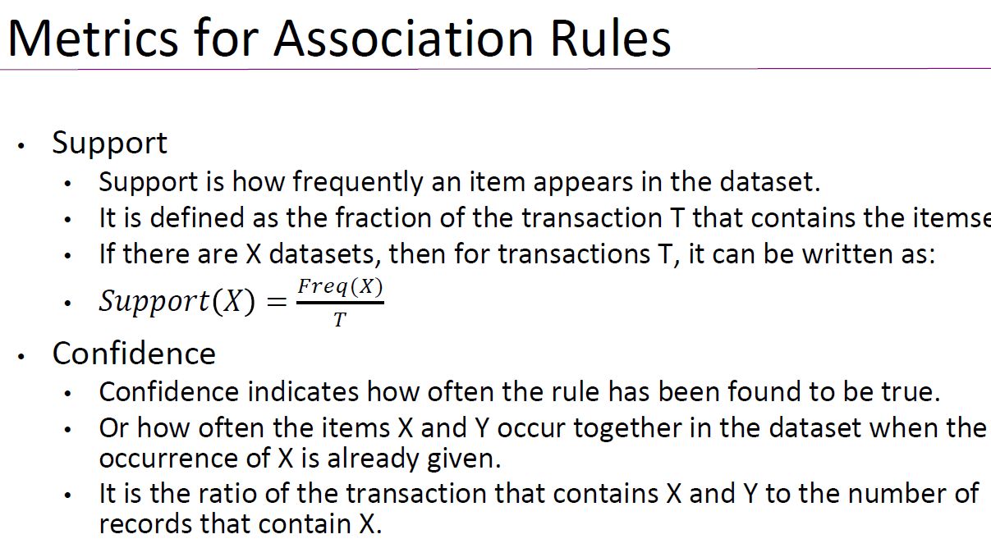

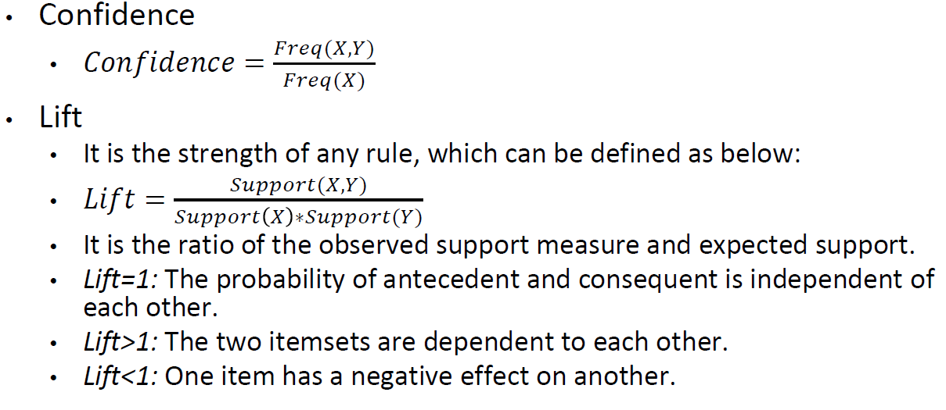

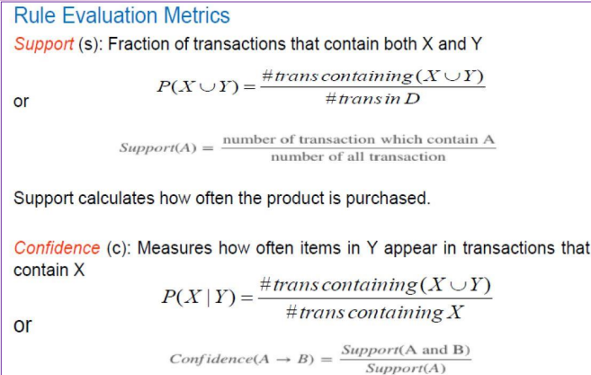

What is an Association Rule
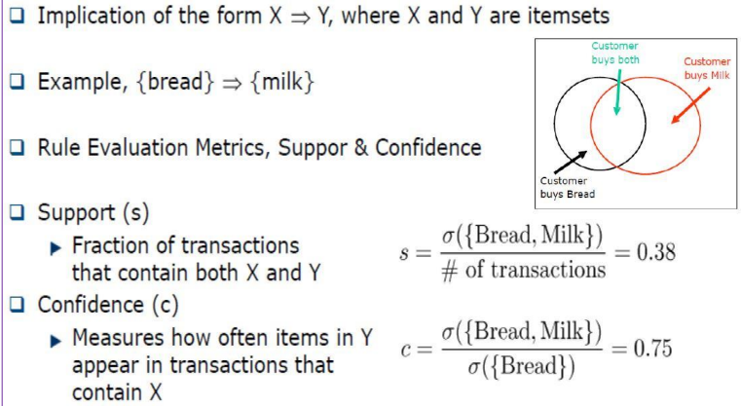

Mining Association Rules
Two step approach
  - Step 1 Frequent Itemset Generation
    - Generate all itemsets whose support >= minsup
  - Step 2 Rule Generation
    - Generate high confidence rules from each frequent itemset where each rule is a binary partitioning of a frequent itemset

*Refer lec slides again

Lecture 08
Ensemble Techniques
- Machine learning models are often trained with a variety of different methods in order to create a more accurate prediction.
- Ensemble methods are one way to do this and involve combining the predictions of several different models in order to get a more accurate result.
- It combines low-performing classifiers and combines individual model prediction for the final prediction.
- Based on the type of base learners, ensemble methods can be categorized as homogeneous and heterogeneous ensemble methods.
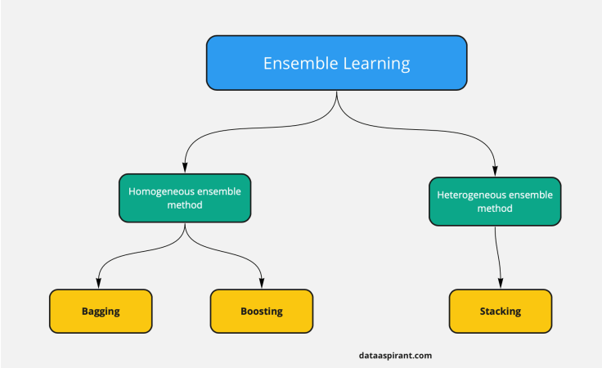

Ensemble Learning Methods
- Bagging
- Boosting
- Stacking

Bagging
- Bagging is an acronym for Bootstrapped Aggregation.
- Bootstrapping means the random selection of records with replacements from the training dataset.
- The idea behind bagging is combining the results of multiple models to get a generalized result.
- Bagging technique works by creating several models, called “bags”, each of which is based on a different randomly selected sample of the data.

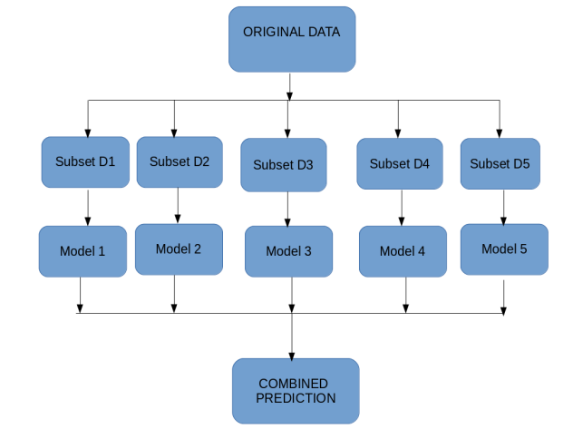

Boosting
- If a data point is incorrectly predicted by the first model, then the next will combining the predictions provide better results? Such situations are taken care of by boosting.
- Boosting is a sequential process, where each subsequent model attempts to correct the errors of the previous model.
- After classification, sample weights are changed. The weight of the correctly classified sample is reduced, and the weight of the incorrectly classified sample is increased.
- Boosting can help data scientists adjust the weights of the models so that better models have more influence on the final prediction.

Stacking
- Stacking uses predictions from multiple models (for example decision tree, KNN or SVM) to build a new model.
- The models are “stacked” on top of each other, and the predictions from each model are combined to produce a final prediction.
- This can be used for regression or classification tasks, and it has been shown to outperform traditional machine learning methods.
- The ultimate model is powerful because it can combine the strengths of different models to produce a more accurate prediction.
- Overall, it is difficult to implement, and it requires a great deal of tuning to get the best results.

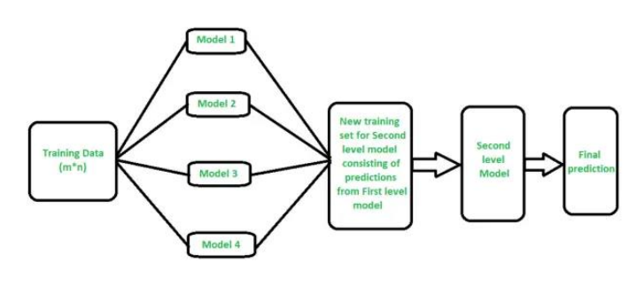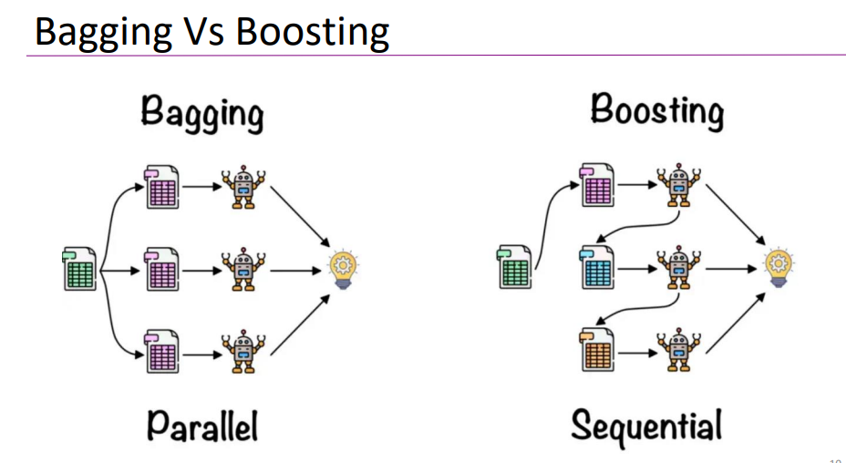
*Refer lec slides again

Lecture 09
Model Evaluation
- Is a process of assessing the model’s performance on a chosen evaluation setup.
- Model selection is the process of choosing the best classifier for a given task.
- It is done by comparing various model candidates on chosen evaluation metrics.

How to evaluate machine learning models?
- Step 1: Choose a proper validation strategy.
- Step 2: Choose the right evaluation metric.
- Step 3: Keep track of your experiment results.
- Step 4: Compare experiments and pick a winner.

Model selection in machine learning
Resampling methods
Simple techniques of rearranging data to inspect if the model performs well on data samples.
Resampling helps us understand if the model will generalize well.

Random split
Used to randomly sample a percentage of data into training, testing, and validation sets.
Will prevent a biased sampling of data: test set is used for model evaluation.

  - Time-Based Split
  - There are some types of data where random splits are not possible.
  - If we must train a model for weather forecasting, we cannot randomly divide the data into training and testing sets.

  - K-Fold Cross-Validation
  - Randomly shuffling the dataset and then splitting it into k groups
  - Model is tested on the test group and the process continues for k groups

  - Stratified K-Fold
  - Unlike in k-fold cross-validation, the values of the target variable are taken into consideration in stratified k-fold.

How to choose performance metrics
Types

Classification metrics
Regression metrics
Clustering metrics

Classification evaluation metrics

For every classification model prediction, a matrix called the confusion matrix can be constructed.

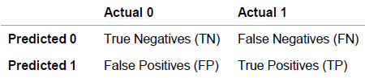

TN: Number of negative cases correctly classified.
TP: Number of positive cases correctly classified.
FN: Number of positive cases incorrectly classified as negative.
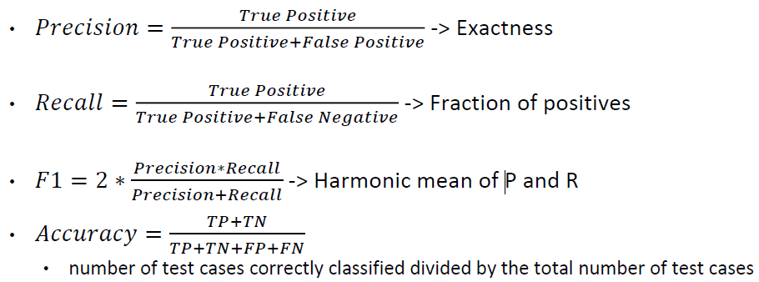
FP: Number of negative cases correctly classified as positive.

AUC-ROC
- ROC curve is a plot of true positive rate (recall) against false positive rate (TN / (TN+FP))
- AUC-ROC stands for Area Under the Receiver Operating Characteristics
- If the curve is somewhere near the 50% diagonal line, it suggests that the model randomly predicts the output variable

Log loss
Very effective classification metric and is equivalent to
-1* log (likelihood function)
Where the likelihood function suggests how likely the model thinks the observed set of outcomes was

Gain & Lift
Lift charts measure the improvement that a model brings in compared to random predictions.
Gain and lift charts evaluate the model on portions of the whole population.

K-S chart
The K-S chart determines the degree of separation between positive class distribution and the negative class distribution.
Higher the difference, the better is the model at separating the positive and negative cases.

Regression evaluation metrics

Regression models provide a continuous output variable, unlike classification models that have discrete output variables.

•Mean Squared Error
Calculates the difference between the actual value and the predicted value (error)

•Root Mean Squared Error
Helps to bring down the scale of the errors closer to the actual values, making it more interpretable

•Mean Absolute Error
Mean of the absolute error values (actuals –predictions)

Clustering evaluation metrics
Clustering algorithms predict groups of datapoints and hence, distance-based metrics are most effective.

Dunn Index
Focuses on identifying clusters that have low variance.

Silhouette Coefficient
Tracks how every point in one cluster is close to every point in the other clusters in the range of -1 to +1

Elbow method
Determine the number of clusters by plotting the number of clusters on the x-axis against the percentage of variance explained on the y-axis.

Trade-offs in model selection

Bias vs Variance
- A model with high bias will oversimplify by not paying much attention to the training points.
- Bias occurs when a model is strictly ruled by assumptions.
- Leads to underfitting when the actual values are non-linearly related to the independent variables.

- A model with high variance will restrict itself to the training data by not generalizing for test points.
- Variance is high when a model focuses on the training set too much.

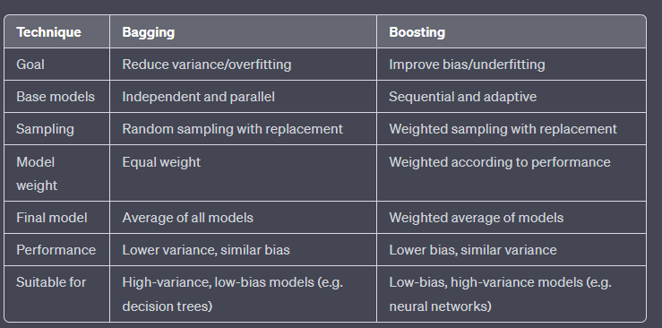

Compare bagging vs boosting:
Are ensemble learning techniques used in ML to improve accuracy and stability.
Bagging (Bootstrap Aggregating)
Bagging (Bootstrap Aggregating) is a popular ensemble learning technique in machine learning that helps to improve the stability and accuracy of machine learning models.
The idea behind bagging is to train multiple independent models on different random subsets of the training data, and then combine their predictions to make a final prediction. This helps to reduce the variance of the model and prevent overfitting.
Bagging works by creating multiple training sets by randomly sampling the original data with replacement, a process called bootstrap sampling. This means that some samples may appear multiple times in a single training set, while others may not appear at all. Each model is trained on a different bootstrap sample, and then the results of all models are combined through averaging or voting, depending on the type of problem being solved.
Bagging is most effective for high-variance, low-bias models like decision trees, which can be prone to overfitting. By averaging the predictions of multiple trees trained on different subsets of the data, bagging can reduce the overall variance and improve the model's generalization performance. However, bagging may not be as effective for models with low variance or high bias.
Some popular algorithms that use bagging are Random Forests, which combine bagging with decision trees, and Extra Trees, which add additional randomness to the construction of each decision tree. Bagging can also be used with other types of models, such as neural networks, support vector machines, and k-nearest neighbors.

Boosting
Boosting is another popular ensemble learning technique in machine learning that aims to improve the accuracy and generalization performance of machine learning models.
The idea behind boosting is to sequentially train a series of weak learners, each of which is trained to improve upon the mistakes of its predecessor. In other words, the algorithm focuses on the examples that were misclassified by previous models, and tries to classify them correctly in the next iteration.
Boosting works by assigning weights to each training example in the dataset, and then training a weak learner on the weighted dataset. The weights are then updated based on the errors made by the weak learner, giving more importance to the misclassified examples. The process is repeated multiple times, with each new weak learner trained on a dataset that has been re-weighted based on the errors of the previous learners. The final prediction is made by combining the predictions of all the weak learners, usually by a weighted sum or a majority vote.
Boosting can be used with different types of weak learners, such as decision trees, neural networks, or linear models. However, it is particularly effective with decision trees, leading to algorithms like AdaBoost (Adaptive Boosting) and Gradient Boosting.
AdaBoost is a popular boosting algorithm that was first introduced in 1995. It works by iteratively training a series of weak learners, each of which is designed to focus on the examples that were misclassified by the previous learners. The final prediction is made by a weighted sum of the predictions of all the weak learners.
Gradient Boosting is another popular boosting algorithm that works by iteratively training a series of decision trees, each of which is trained to minimize the residual errors of the previous trees. In other words, each new tree is trained to improve upon the errors made by the previous trees. The final prediction is made by summing the predictions of all the trees.
Boosting is effective in reducing both bias and variance of the model, and it can often outperform other machine learning algorithms on a wide range of problems.
Data Imbalancing
Data imbalance refers to a situation where the distribution of classes or labels in a dataset is not equal. In other words, when the number of examples belonging to one class is significantly higher or lower than the number of examples belonging to another class in a given dataset.
There are several techniques that can be used to address data imbalance in a dataset, including:

- Undersampling: This involves removing examples from the majority class to balance the number of examples in each class.

- Oversampling: This involves creating more examples of the minority class by duplicating existing examples or generating new synthetic examples.

- Combination of undersampling and oversampling: This involves a combination of both undersampling and oversampling techniques.

- Using a different evaluation metric: Instead of using accuracy as the evaluation metric, we can use other metrics such as F1-score, AUC-ROC, or precision and recall, which are better suited to imbalanced datasets.

- Modifying the algorithm: Some algorithms such as decision trees and random forests can be modified to take into account the class imbalance by adjusting the weights of the classes.

- Data augmentation: This involves creating new examples by applying transformations to the existing examples.

- Collecting more data: Collecting more data for the minority class can help to balance the dataset.

Tips and tricks to keep in mind when releasing a dataset from your own:

- Determine your dataset's purpose and audience: Before releasing your dataset, you should have a clear idea of who will use it and for what purpose. This will help you decide how to structure and format your dataset to make it accessible and useful to your intended audience.

- Ensure data privacy and security: Ensure that the data you release does not contain any personal information that could identify individuals. Also, consider taking measures to protect the data's privacy and security, such as anonymizing data, encrypting data, or using access controls.

- Choose the right data format: Choose a format that is easily accessible and compatible with the software and tools used by your intended audience. Common data formats include CSV, JSON, and XML.
- Provide clear documentation: Clear documentation will help others understand your dataset's structure, variables, and any quirks. This documentation can include a data dictionary, readme file, or user manual.

- Host the dataset on a reliable platform: Choose a reliable platform to host your dataset, such as a data repository, cloud service, or web server. This will ensure that your dataset is accessible and available to your intended audience.

- Consider licensing: Consider licensing your dataset to specify how others can use it. Popular licenses for datasets include Creative Commons licenses or Open Data Commons licenses.

- Promote your dataset: Promote your dataset to reach a wider audience, such as through social media, academic conferences, or data-focused websites.

By following these tips and tricks, you can release a dataset that is accessible, secure, and useful to others.

